NAAN MUDHALVAN – SMART BRIDEG PROJECT

PROJECT TITLE: JOB APPLICATION TRACKING SYSTEM

SUBMITTED BY

TEAM LEAD: BALAMURUGAN.T (CB20S377313)

TEAM MEMBER 1: BARATHKUMAR.S (CB20S377314)

TEAM MEMBER 2: DEVIKA.A (CB20S377315)

TEAM MEMBER 3: DHANALAKSHMI.S (CB20S377316)

INDEX

|  |  |  |
| --- | --- | --- |
| S.NO | CONTENT | PAGE NO |
| 1 | INTRODUCTION |  |
| 2 | Problem Definition & Design Thinking |  |
| 3 | Activity & Screenshot |  |
| 4 | Trailhead Profile Public URL |  |
| 5 | ADVANTAGES & DISADVANTAGE |  |
| 6 | APPLICATIONS |  |
| 7 | CONCLUSION |  |
| 8 | FUTURE SCOPE |  |

*INTRODUCTION*

Are you new to Salesforce? Not sure exactly what it is, or how to use it? Do not know where you should start on your learning journey? If you’ve answered yes to any of these question, then you’re in the right place. This module is for you.

Welcome to salesforce! Salesforce is game changing technology,with a host of productivity-boosting feature, that will help you sell smarter and faster. As you work toward your badge for this module,we’ll take you through these features and answer the question, “What is salesforce,anyway?”

* When an applicant submits their resume for a job of their liking and interest, the ATS captures the applicant information. Information such as the applicant skill sets, experience, educational background, contact information, resume and covering letting can be uploaded into the system database.
* As the hiring process progresses, this information can be seamlessly transferred from system to system. Recruiters can review applicant information, shortlist and review if found suitable for requirements

The ATS thereby, cohesively streamlines the recruiting and application process with other networks and systems in the organization.

OVER VIEW

* An applicant tracking system (ATS) is software that manages the recruiting and hiring process, including job postings and job applications.
* It organizes information about job seekers and makes it searchable.
* As its name implies, an ATS tracks candidates through the hiring process.

EMPATHY MAP

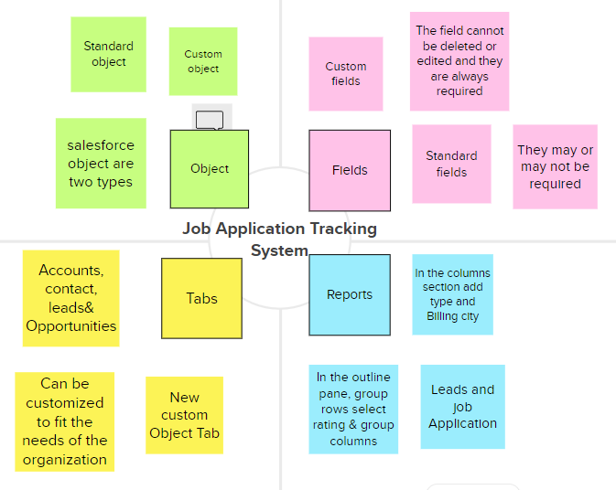

BRAIN STORMING MAP

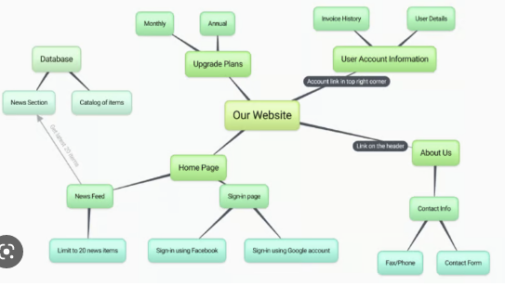

Milestone 1- Creating salesforce developer Org:

A Developer org has all the features and licenses you need to get started with Salesforce.

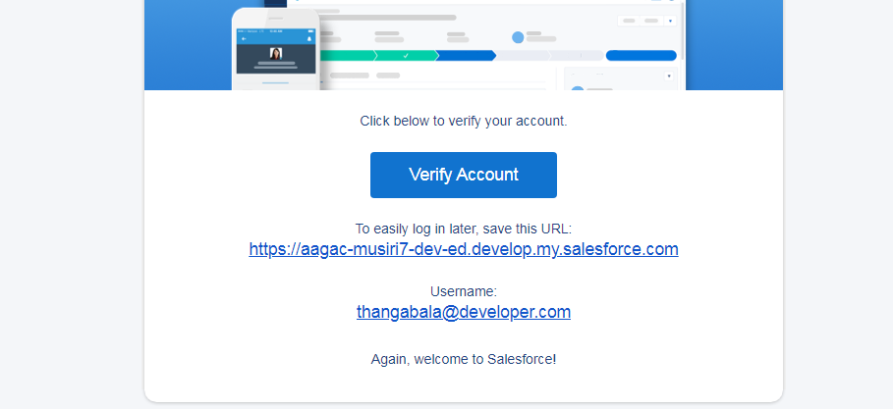

Account Activation.

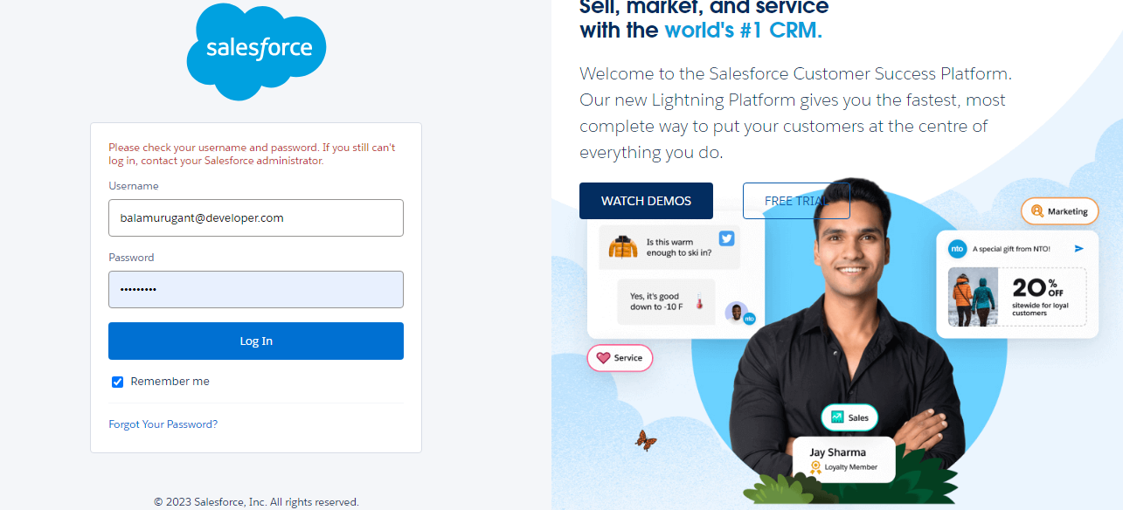

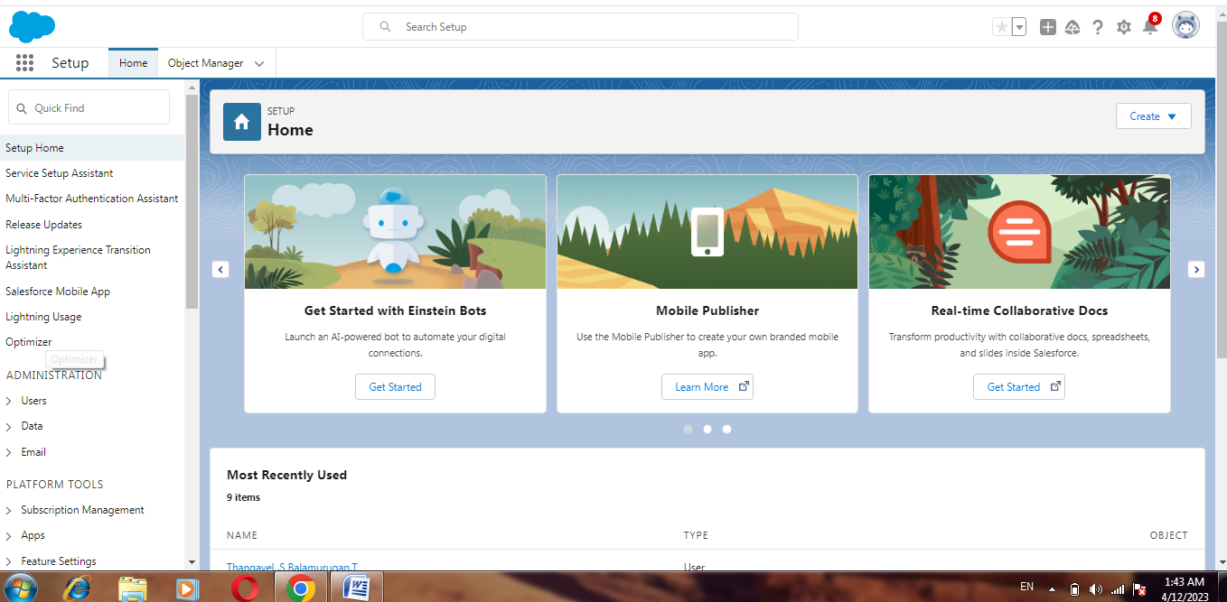

Milestone 2- Object:

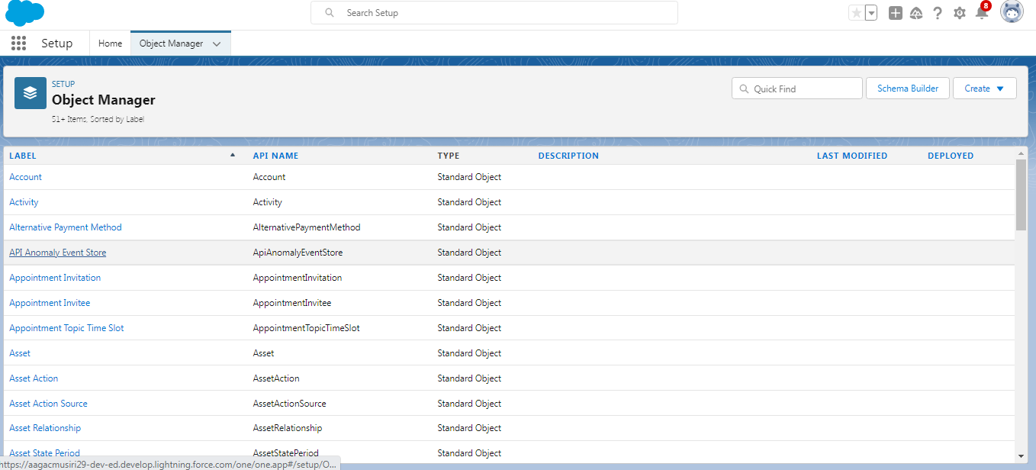

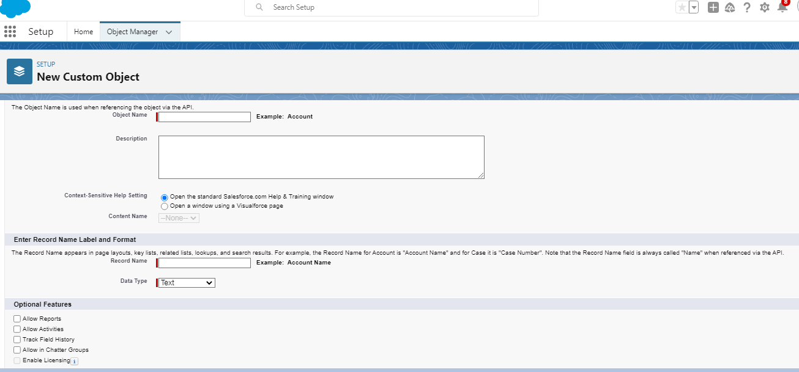

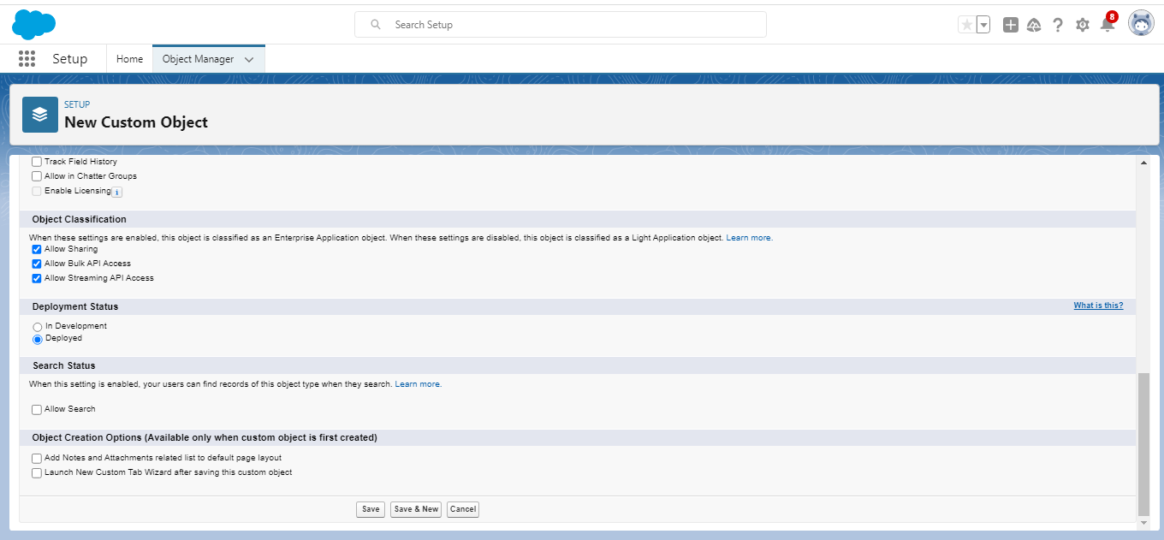

Milestone 3-Fields

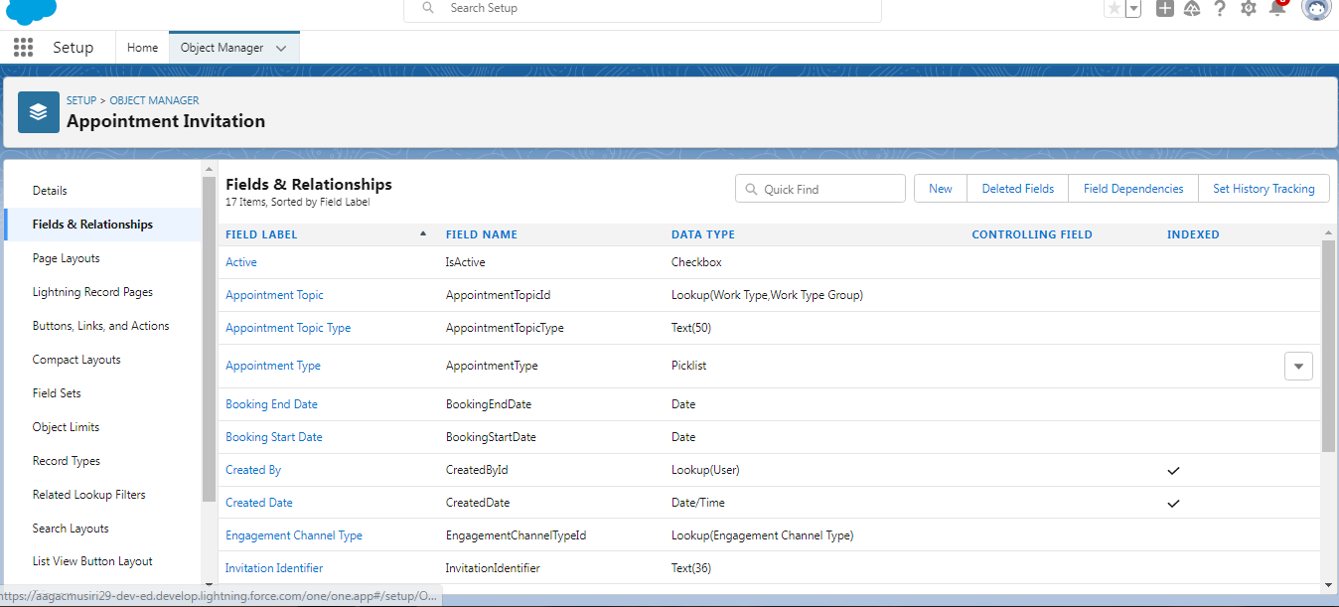

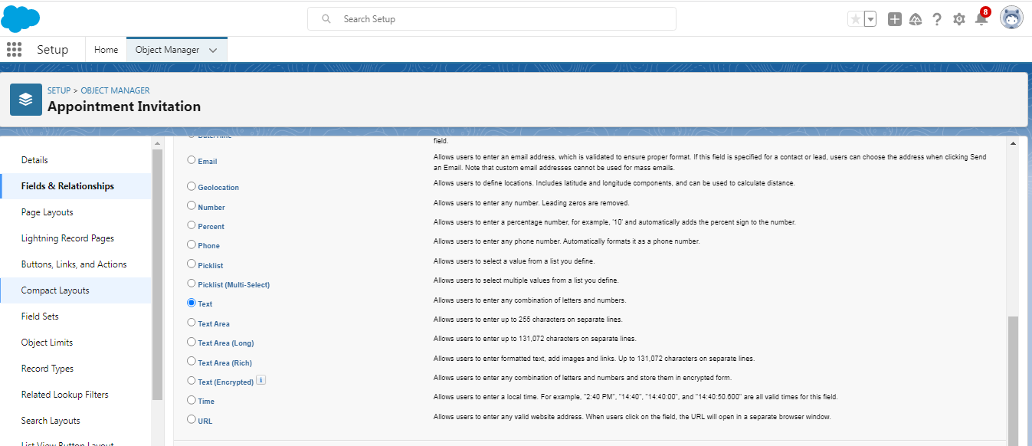

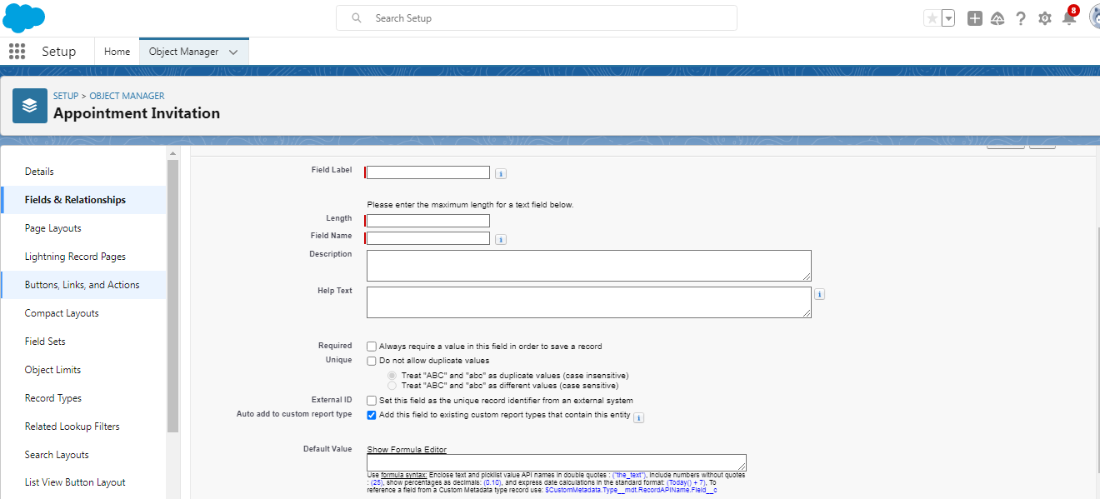

Milestone 4-Tab:

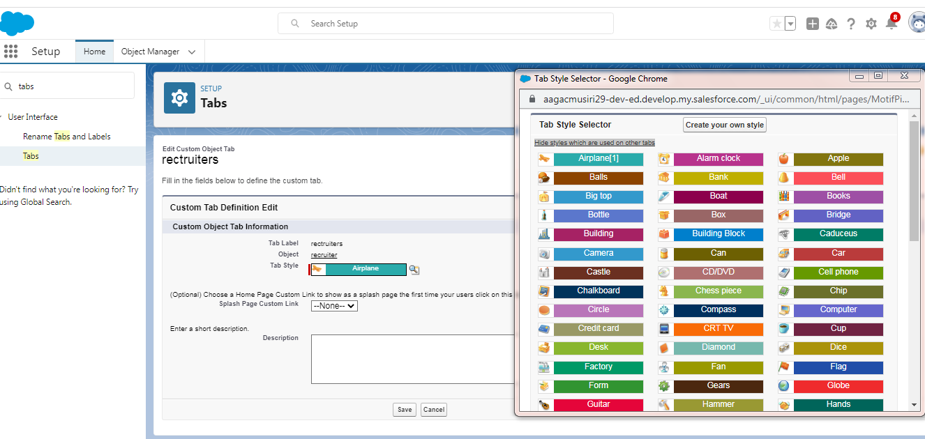

Milestone 5: profile

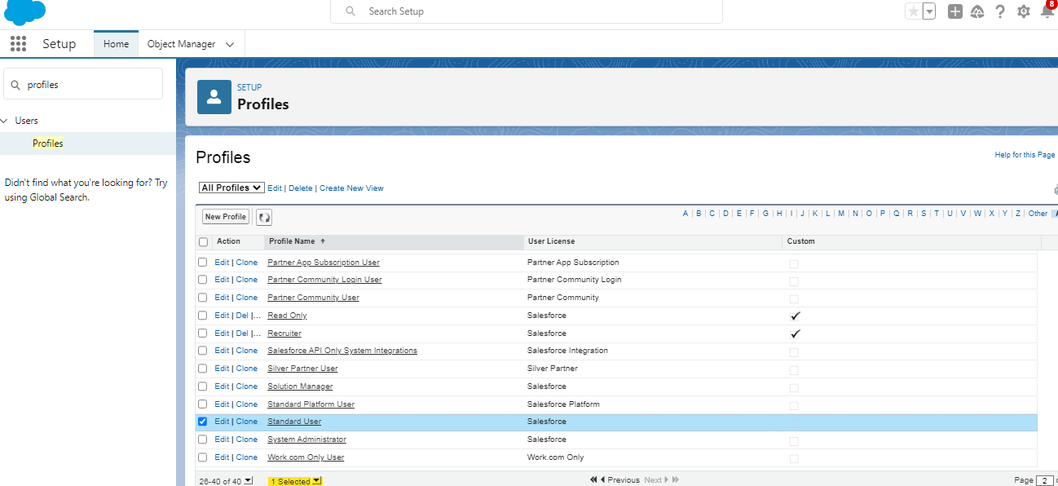

Milestone 6: User

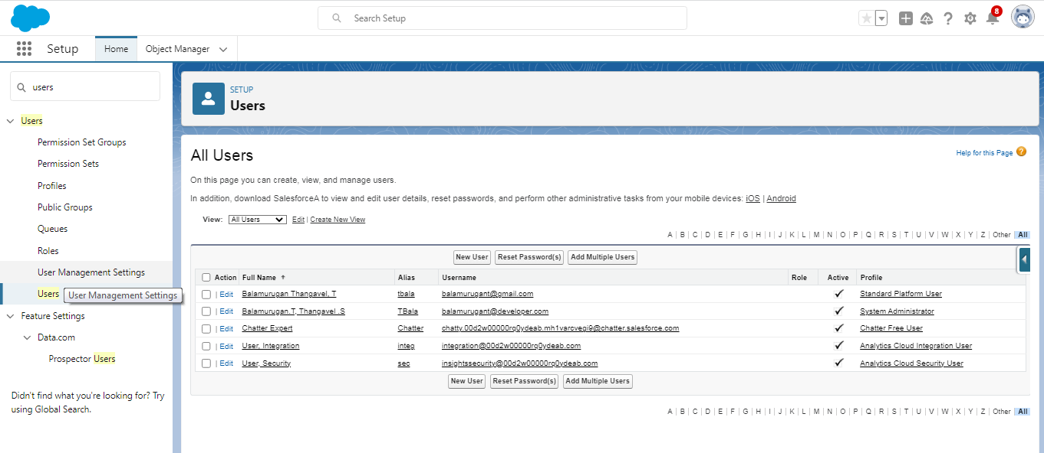

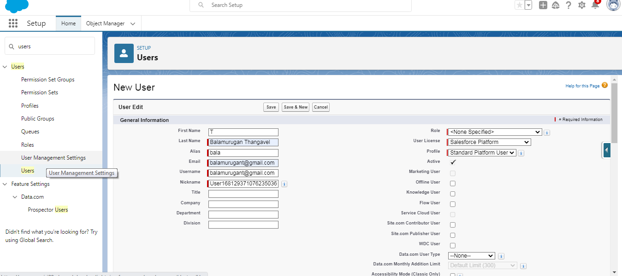

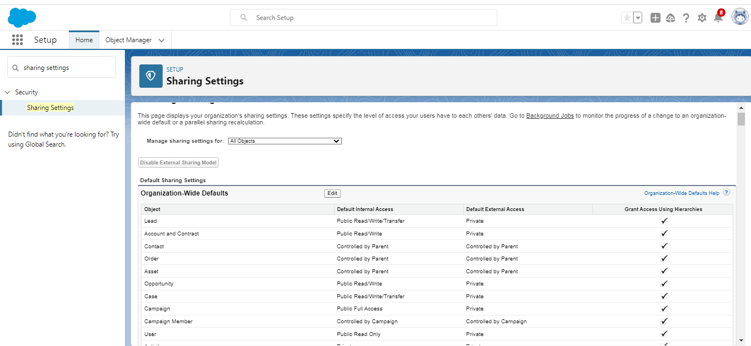

Milestone 8: Reports

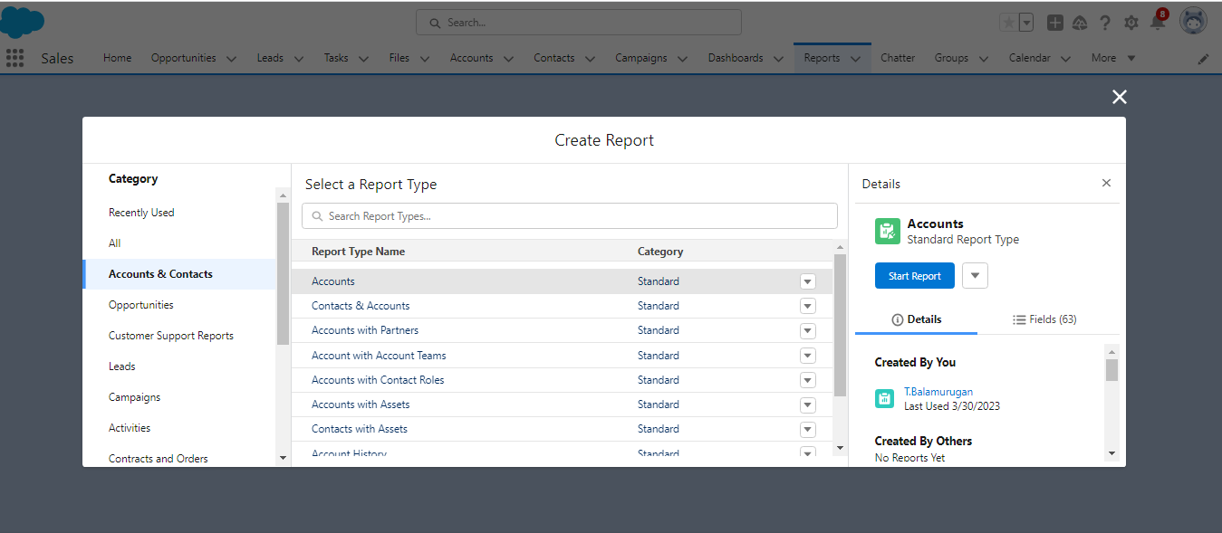

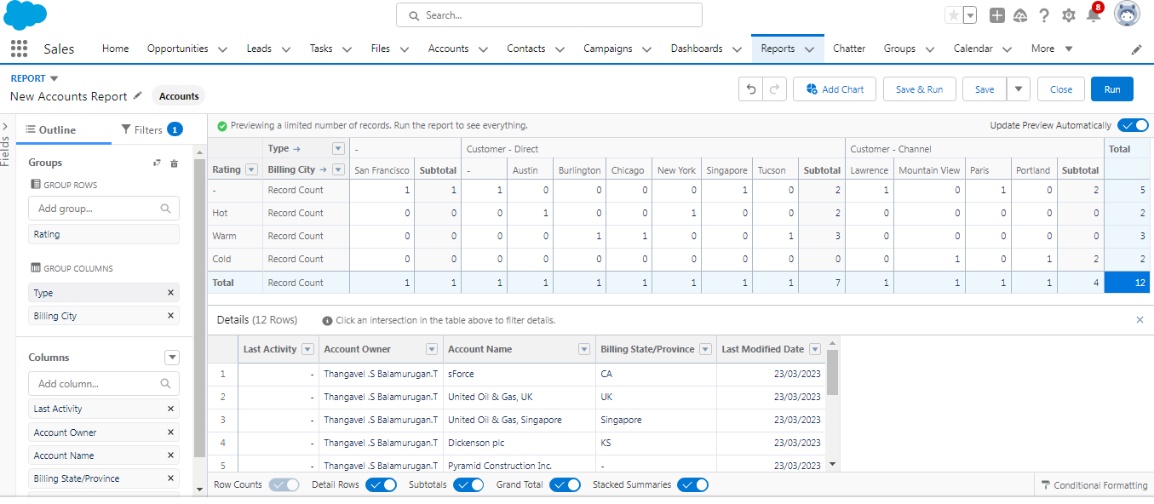

Trailhead profile public URL

Team Lead –https://trailblazer.me/id/tbalamurugant

Team member1- https://trailblazer.me/id/sbarathkumar

Team member2- https://trailblazer.me/id/adevika6

Team member3-https://trailblazer.me/id/ddhanalakshmi3

ADVANTAGES & DISADVANTAGE

Hiring and tracking applicants is more complex than ever before with hiring managers and recruiters stretched thin to evaluate mass amounts of candidates and find the proverbial needle in a haystack. For a quick, expedited process to find the “perfect candidate”, recruiters and hiring managers have turned to , including Applicant Tracking Systems (ATS), to improve almost every aspect of the recruiting process.

1. **Reduces time spent on admin tasks.** ATS software allows you to automate various tasks of the hiring process that can save you a lot of time and free up your recruiting personnel for other high-value tasks. Posting to multiple job boards, tracking candidate applications, notifying candidates individually, and scheduling interview feedback can all be automated. Not only will it speed up the time it takes to do all of those tasks, it will increase the overall quality through standardization.
2. **Resume and CV screening.** With recruiters receiving 100s of resumes per role, even scanning can take a lot of time. ATS software can be utilized to review applications and filter out candidates that don’t meet the minimum requirements of the role. So, the number of resumes a recruiter needs to review can be reduced drastically using pre-screening questions or word searches within resumes. Once again, a recruiter’s time can be redirected to higher value items of the business.
3. **Speeds up the recruitment cycle.** Having candidates’ information centralized on a single platform gives recruiters access to organized information allowing them to review and compare candidates more easily and quickly, which leads to a lower cost-per-hire. All communications, including notes, interviewer ratings, cases, and more can be stored and viewed in one location, which simplifies and speeds up the evaluation process.
4. **Improves the quality of hire.** Not only do ATS’s create more efficient workflows, as previously discussed, they can also improve the quality of your hire. First, you were able to cast a wider net by posting on job boards with standardized messaging to attract more candidates. Second, you used automated matching and filtering weed out unqualified candidates.

DISADVANTAGES

* **Could filter out good candidates.** When “programming” your recruiting software to recognize common keywords around roles and responsibilities, you could end up filtering out good candidates that have atypical experience or lack keywords that are aligned with what you are looking for. Careful consideration of your filters and a quality assurance process will help to fine tune the filter and reduce filtering out good candidates. This can happen with manual reviews as well, so automation, in most situations, has a net benefit.
* **Communications can be less personalized.** When automating responses to candidates, your messaging will be less personalized and can come off as robotic. Taking additional time to construct good communication can help make it feel more personalized. It’s much better to send a less personalized communication than no communication at all.

APPLICATIONS

An [Applicant Tracking System](https://www.jobscan.co/blog/what-is-an-applicant-tracking-system/) or ATS is an all-in-one human resource software that automates the hiring process, helps HR teams efficiently manage every part of recruitment (from job posting to onboarding), and solves recruiters’ challenges and pain points.

Specifically, the ATS:

* Stores job candidate information like resumes, cover letters, references, and other recruitment and hiring data that HR teams can easily access and organize.
* Tracks job candidates and their application status throughout the hiring pipeline.
* Weeds out unqualified candidates and recommends the best fit for a position based on the parameters set by HR. Only those on the shortlist are moved to the next stage of the hiring process.
* Automates time-consuming administrative tasks such as manually screening applicants, reading resumes, scheduling interviews, and sending notifications and emails to job candidates and employees.

CONCLUSION

An applicant tracking system (ATS) helps companies organize candidates for hiring and recruitment purposes. These systems allow businesses to collect information, organize prospects based on experience and skill set, and filter applicants

FUTURE SCOPE

Many people introduce themselves by stating their name and current job title, but you are also required to try to add information your new contact cannot find on your business card. If you are at a networking event, consider starting with your name, then stating what your passion is. You could also mention what your goal is for the encounter, such as finding someone to collaborate with on a new idea you have.

When you are[interviewing for a job](https://in.indeed.com/career-advice/interviewing/how-to-introduce-yourself-in-an-interview), quickly summarise who you are and why you are there. Your interviewers already know what position you are applying for, so have your professional introduction explain your purpose in a few sentences. You are required to include your name and why you are a good candidate for the job.

Keep in mind that you are required to start your introduction in a way that is appropriate for the context. For example, if you are at a networking event, you might simply start by shaking a new connection's hand and giving them your first and last name. Then, begin a conversation by asking and answering questions about their background and your own.